**Data Flow Diagram:**

Project Design Phase-II

Data Flow Diagram & User Stories

|  |  |
| --- | --- |
| Date | 15 Nov 2022 |
| Team ID | PNT2022TMID29172 |
| Project Name | Project - Real-Time Communication System Powered by AI for Specially Abled |
| Maximum Marks | 4 Marks |

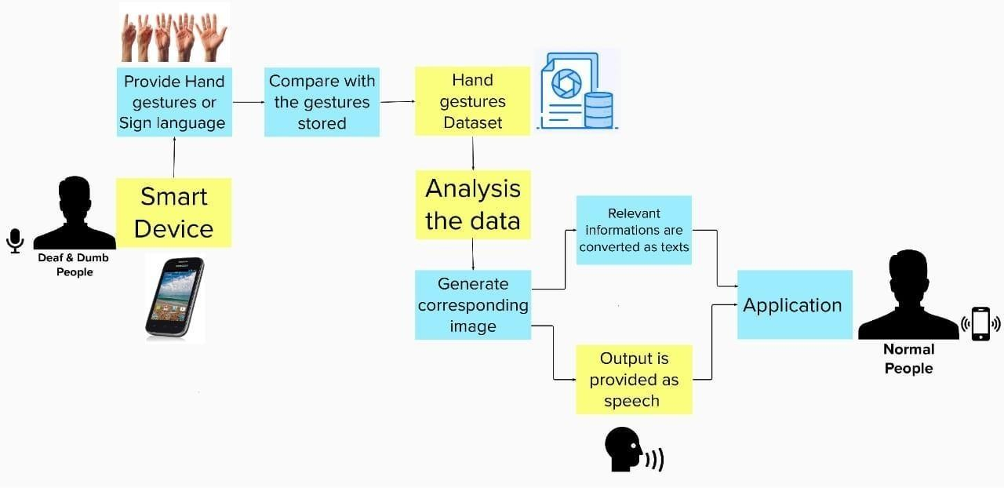

**User Stories**

Use the below template to list all the user stories for the product.

|  |  |  |  |  |  |  |
| --- | --- | --- | --- | --- | --- | --- |
| **User Type** | **Functional Requirement**  **(Epic)** | **User Story Number** | **User Story / Task** | **Acceptance criteria** | **Priority** | **Release** |
| Customer (Mobile user) | Register with the users information. | USN-1 | As a user, I can register for the application by  entering my email, password, and confirming my password. | I can access my account / dashboard in the application. | High | Sprint-1 |
| Customer (Deaf people) | To communicate  with people using signs. | USN-2 | As a user, I can see my application and made changes in any browser and register to it. | I can login and see my  account in the application anywhere at anytime. | High | Sprint-1 |
| Customer (Dumb people) | To communicate  with people easily and efficiently. | USN-3 | As a user, I can see my application and made changes in any browsers and register to it. | I can login and see my  account in the application anywhere. | High | Sprint-1 |
| Customer (Normal people) | User needs to communicate with  specially abled people. | USN-4 | As a user, I can register for the application by entering my email, password, and confirmation is made. | I can login and see my account. | Medium | Sprint-2 |
| Customer (Learner of Sign language) | User needs to be aware and learn  about sign language. | USN-5 | As a user, I can create my account in the application with my email and password, to get knowledge about sign languages. | I can create my account and access the dashboard in the application. | High | Sprint-1 |
| Customer (Web user) | They want the update on the application condition. | USN-6 | As a user, I can register for the application by entering my email, password, and confirming my password. To get details about real-time communication. | I can able to use any browser to access the application from anywhere, to know  anything about real-time communication. | High | Sprint-1 |
| Customer Care Executive | They want to help people by sending  application conditions. | USN-7 | As a user, I can receive a message from  the administration about conditions of application of real-time communication. | I will analyse and send SMS to the people. | High | Sprint-1 |